**Lab 5**

1. Given the length and breadth of a rectangle, write a program to find whether the area of the rectangle is greater than its perimeter. For example, the area of the rectangle with length = 5 and breadth = 4 is greater than its perimeter.

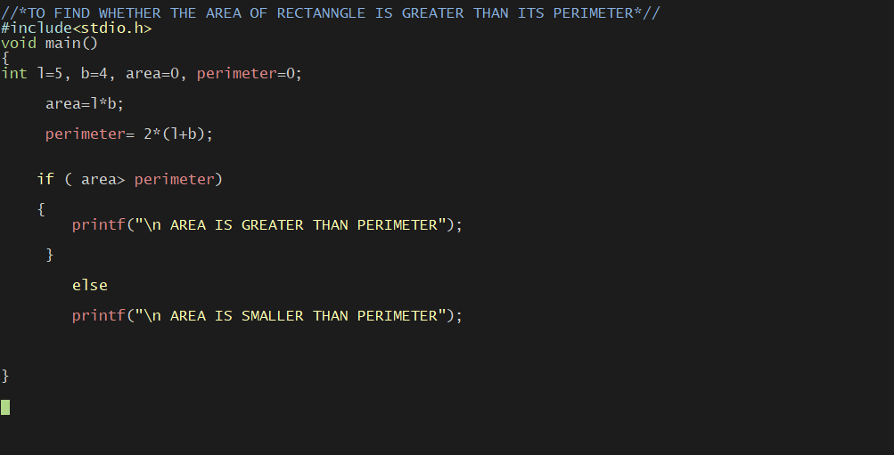

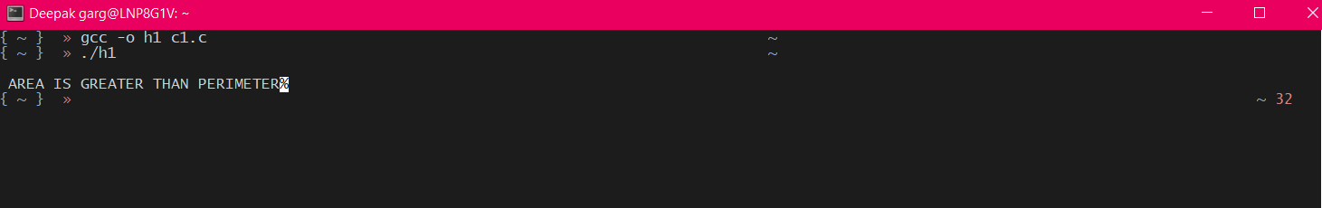

1. Write a program in C to enter a year and check whether it is leap year or not.

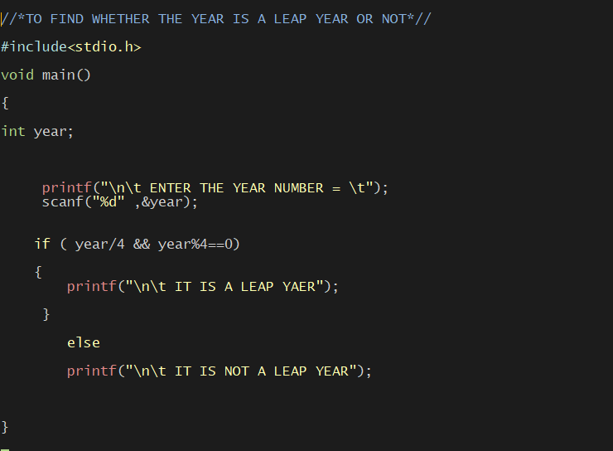

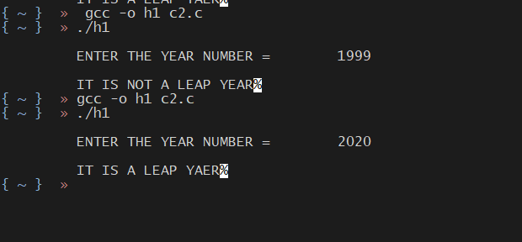

1. Write a program to check whether a triangle is valid or not, when the three angles of the triangle are entered through the keyboard. A triangle is valid if the sum of all the three angles is equal to 180 degrees.

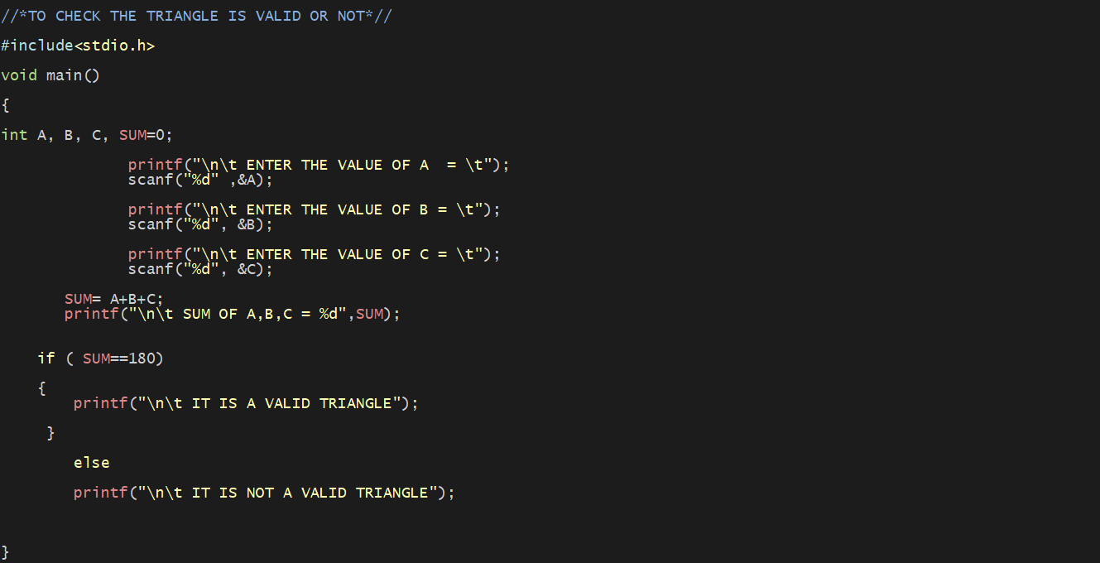

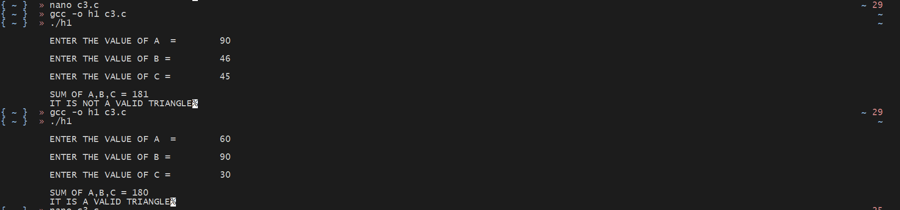

1. WAP to input three sides of the triangle and check whether it is Equilateral, Isosceles or Scalene triangle.

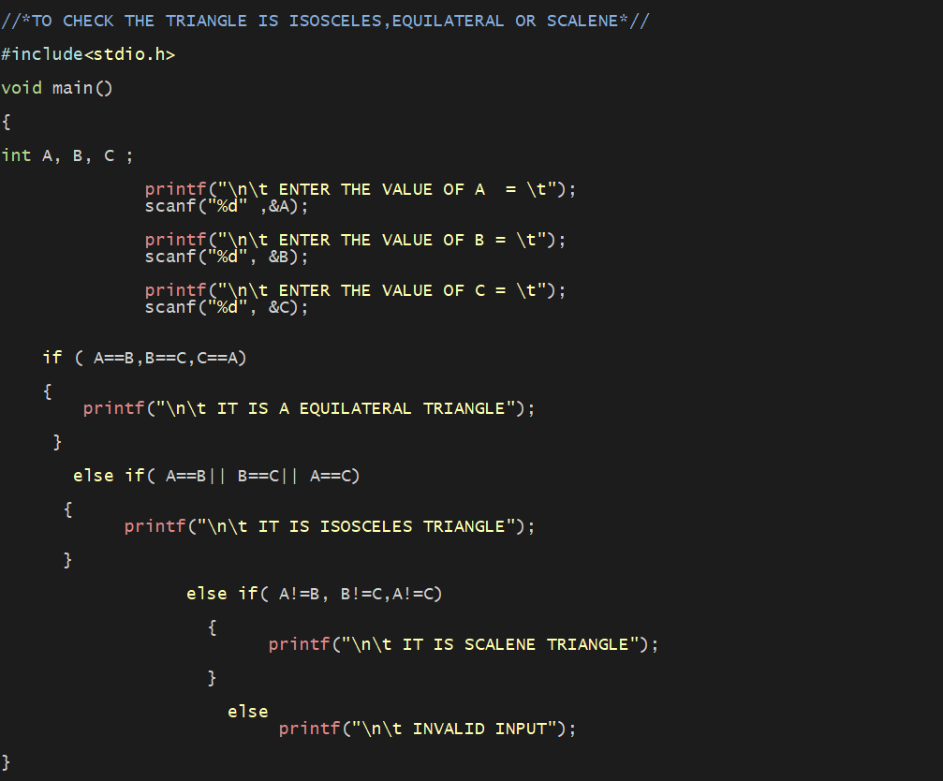

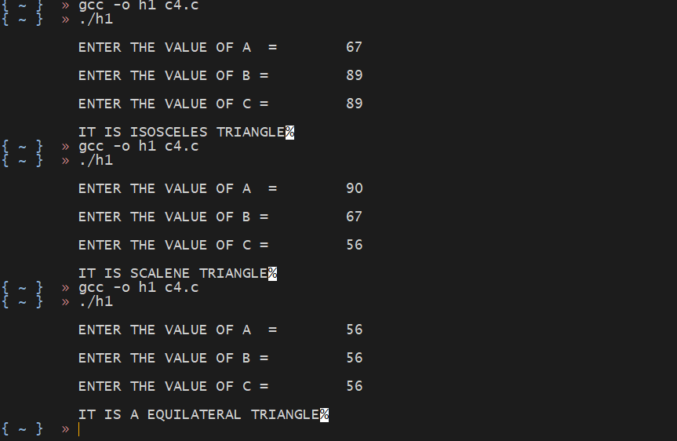

1. WAP in C if a person’s basic salary is input through the keyboard. His dearness allowance is 30% of basic salary, and house rent allowance is 10% of basic salary. Write a program to calculate his gross salary.

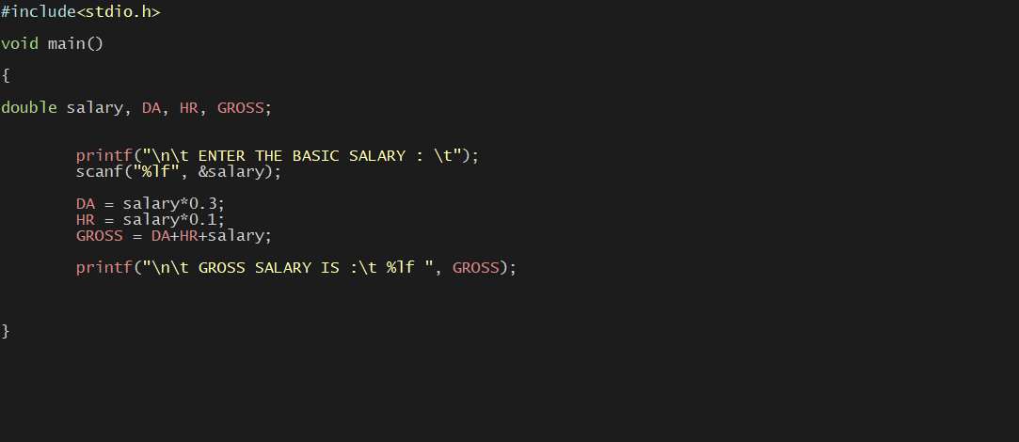



1. If the ages of Ram, Shyam and Ajay are input through the keyboard, wap in C to determine the youngest of the three.

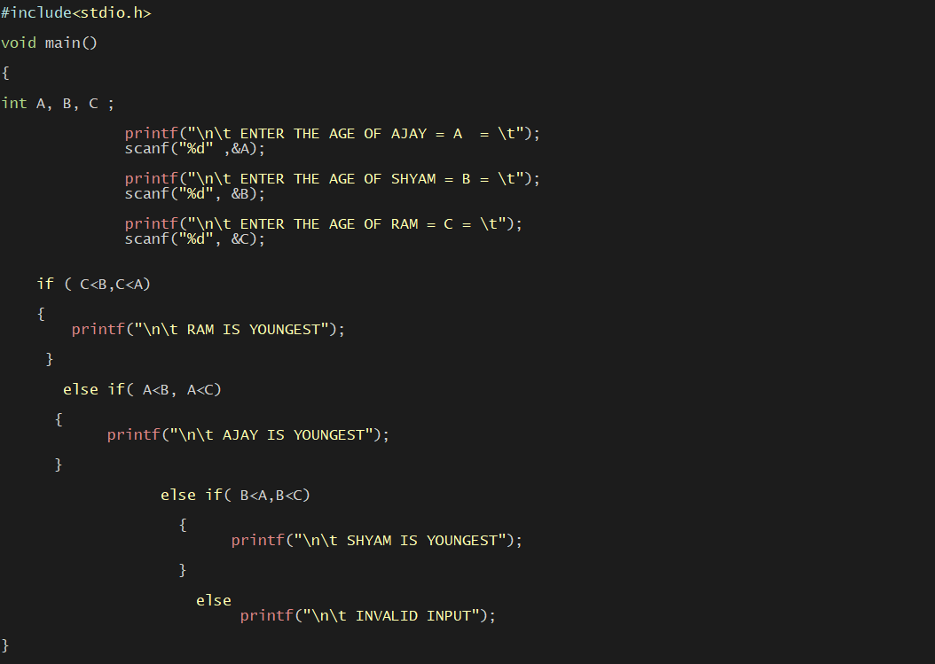



1. Write a program in C to simulate calculator to perform the following operations on two numbers on the basis of choice entered as below else print a message “invalid operation”
2. Addition.
3. Subtraction.
4. Multiplication.
5. Division

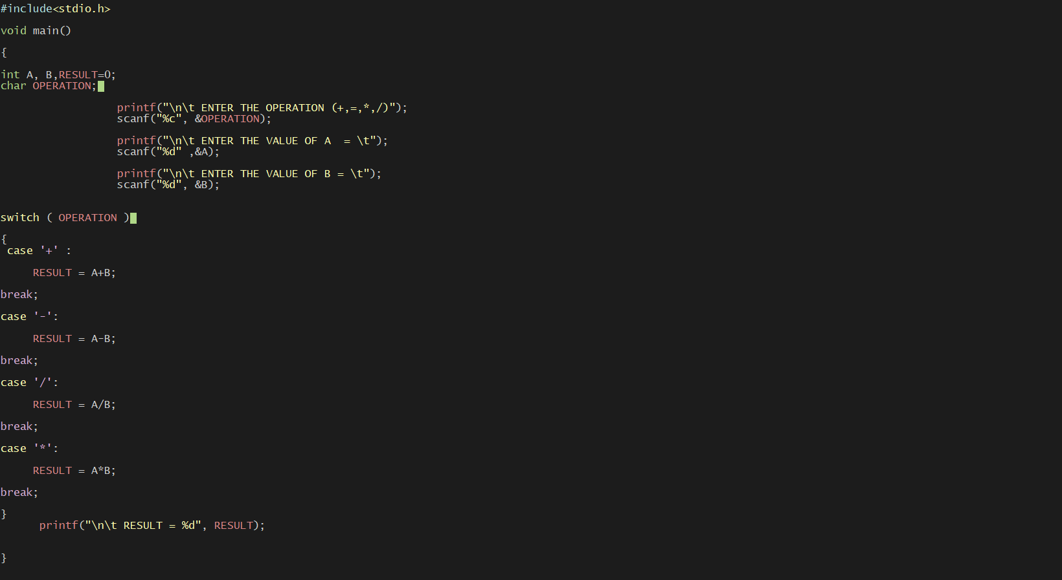

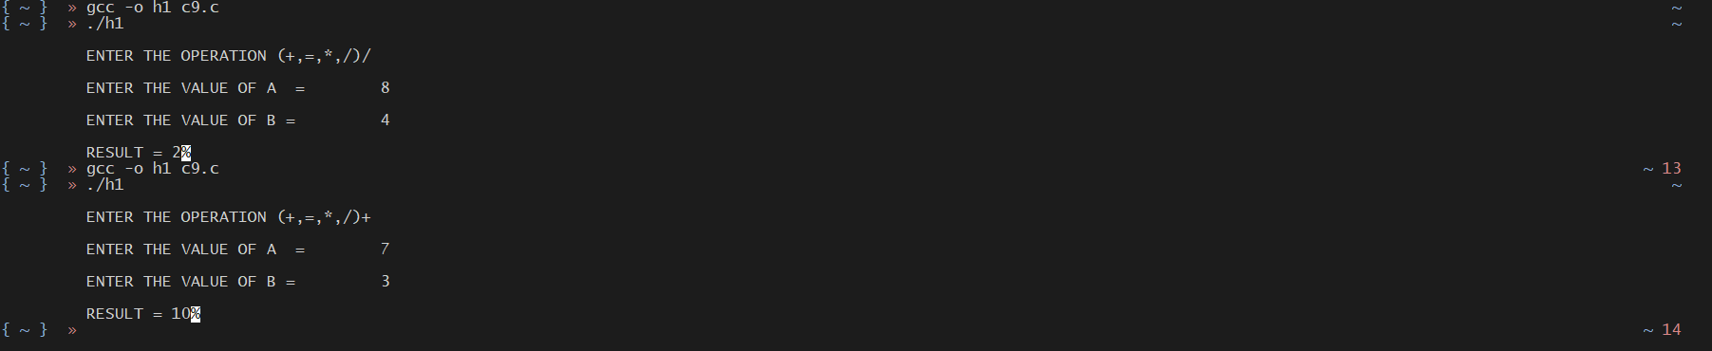

1. The marks obtained by a student in 5 different subjects are input through the keyboard. The student gets a division as per the following rules:

Percentage above or equal to 60 - First division

Percentage between 50 and 59 - Second division

Percentage between 40 and 49 - Third division

Percentage less than 40 - Fail

WAP in C to calculate the division obtained by the student.(Use Logical operators)

